Grade 7 Accelerated · Unit 6 · Lesson 5  Distance on the Coordinate Plane  Question Bank 6.05 ANSWER KEY | Name  Date  Period

Show your work. Circle your final answer.
For questions 1 through 7, find the distance between the two points. Round to the nearest tenth when it is not a whole number.
1. 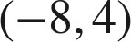 and 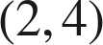
10 units
Same y.

2. 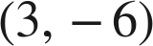 and 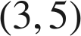
11 units
Same x.

3. 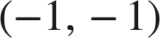 and 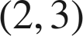
5 units
Across 3, up 4.

4. 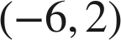 and 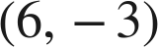
13 units
Across 12, down 5.

5. 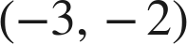 and 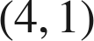
√58 ≈ 7.6 units
Across 7, up 3.

6.  and 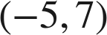
√74 ≈ 8.6 units
Legs 5 and 7.

7. 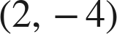 and 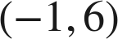
√109 ≈ 10.4 units
Across 3, up 10.

Choose one.
8. What is the distance between 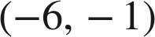 and 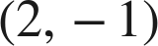?
○ A. 4
○ B. −8
○ C. 9
● D. 8
D
Same y: 2 − (−6) = 8.

9. Which gives the distance between 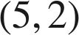 and 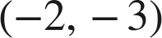?
● A. 
○ B. 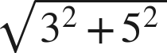
○ C. 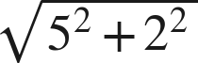
○ D. 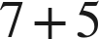
A
Across 7, down 5: √74.

